Change Plan Name in Mobius

# Purpose

We recently ran into the situation in which a plan name didn’t make sense, but the plan was already approved in RayStation, so we couldn’t change the name. But we could make Mobius use a better plan name. Here’s how to export DICOM from RayStation, change the plan name in the exported plan files, and upload the edited DICOM files to Mobius.

# Steps

This example uses a plan called *3 Fd. R Breast* that actually has four fields, so we want Mobius to say *4 Fd. R Breast* instead.

Here’s the plan name in Mobius:



The plan name can’t be changed in RayStation because the plan is approved:



1. Export all DICOM files associated with the plan, to a file. We recommend exporting to a new folder in the Temp directory because you’ll delete the exported files after uploading them to Mobius. Apply the DICOM filter that changes the prescription name.

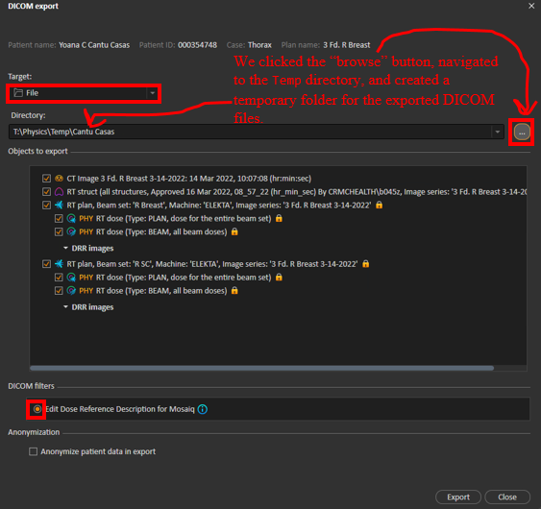

1. Double-click your Desktop shortcut to open the Dicom Editor.

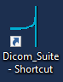

1. The Dicom Editor will prompt you for a DICOM file to open. Navigate to the temporary export folder and select an RT plan file. An RT plan filename exported from RayStation starts with *RP*.

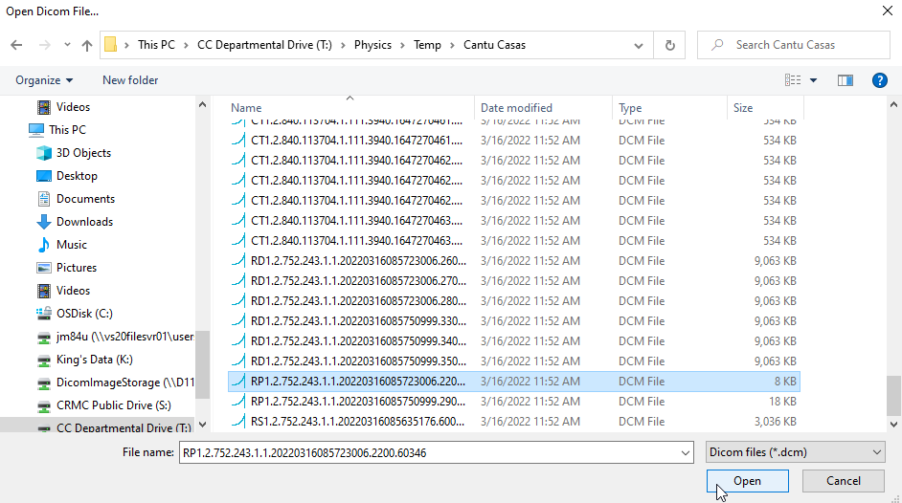

1. Double-click the **RT Plan Name** row in the Dicom Editor. The **Edit Long String** window will appear.

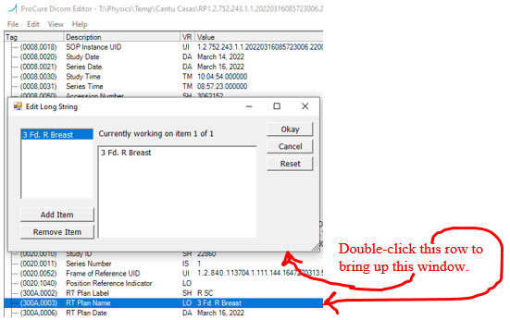

1. In the **Edit Long String** window, correct the plan name and click **Okay**.

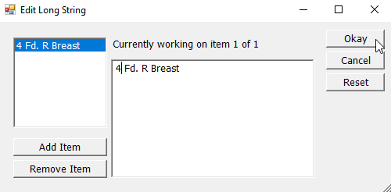

1. Go to **File** > **Save Dicom File**. Note that Ctrl+S to save does not work.

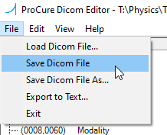

1. The following window should appear. Click **OK**.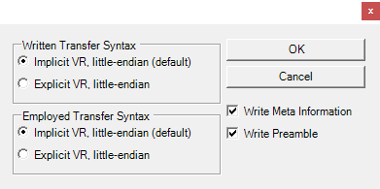
2. In the **Save Dicom File…** dialog, select the plan file you opened in the Dicom Editor and click **Save**.

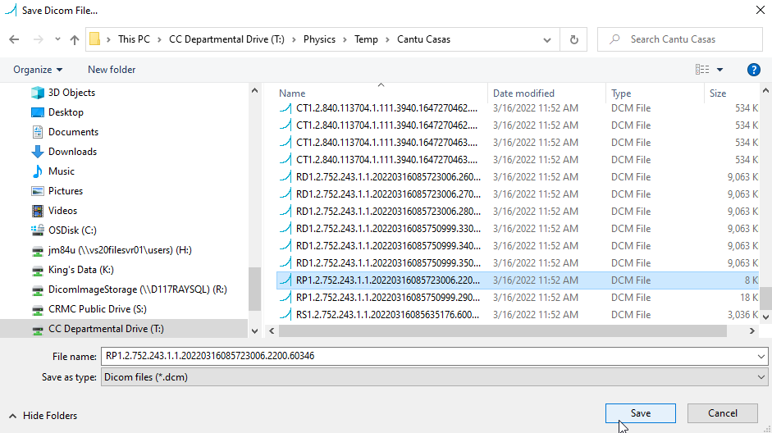

1. Click **Yes**. This overwrites the file with the incorrect plan name, with the edited file.

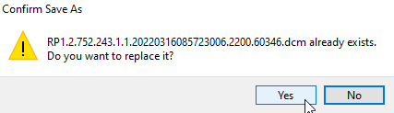

1. Zip the DICOM files for upload to Mobius. Right-click the temporary folder, hover over **Send to**, and select **Compressed (zipped) folder**.

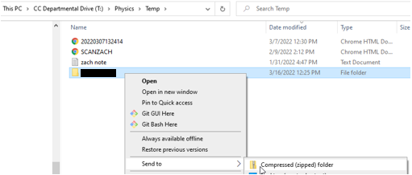

1. Upload the zip file to Mobius. See procedure Manually Upload DICOM Files to Mobius.
2. When the plan check completes, you should see that the new plan has the corrected name:



1. Delete the plan check of the incorrectly named plan.
2. Delete the temporary export folder.